## Logic For First Submission

**<Properly explain the code, list the steps to run the code provided by you and attach screenshots of code execution>**

**Note:** Be as descriptive as possible.

**Task1** : **Write a job to consume clickstream data from Kafka and ingest to Hadoop.**

**Steps**:

1. Import all libraries required for running the code.

import os

import sys

os.environ["PYSPARK_PYTHON"] = "/opt/cloudera/parcels/Anaconda/bin/python"

os.environ["JAVA_HOME"] = "/usr/java/jdk1.8.0_161/jre"

os.environ["SPARK_HOME"] = "/opt/cloudera/parcels/SPARK2-2.3.0.cloudera2-1.cdh5.13.3.p0.316101/lib/spark2/"

os.environ["PYLIB"] = os.environ["SPARK_HOME"] + "/python/lib"

sys.path.insert(0, os.environ["PYLIB"] + "/py4j-0.10.6-src.zip")

sys.path.insert(0, os.environ["PYLIB"] + "/pyspark.zip")

from pyspark.sql import SparkSession

from pyspark.sql.functions import *

1. Initialize the spark session and set app name as Kafka to local

spark = SparkSession \

.builder \

.appName("Kafka-to-local") \

.getOrCreate()

1. Read data from Kafka by subscribing to **de-capstone3 topic**

df = spark.readStream \

.format("kafka") \

.option("kafka.bootstrap.servers", "18.211.252.152:9092") \

.option("startingOffsets", "earliest") \

.option("subscribe", "de-capstone3") \

.load()

1. Drop the columns which are not required and change the column name of value to value_str

df= df \

.withColumn('value_str',df['value'].cast('string').alias('key_str')).drop('value') \

.drop('key','topic','partition','offset','timestamp','timestampType')

1. Write the data to hadoop using below code. We have to use path where the raw clickstream data is stored as well as checkpoint path in HDFS

df.writeStream \

.format("json") \

.outputMode("append") \

.option("path", "/user/root/clickstream_dump_op") \

.option("checkpointLocation", "/user/root/clickstream_dump_cp") \

.start() \

.awaitTermination()



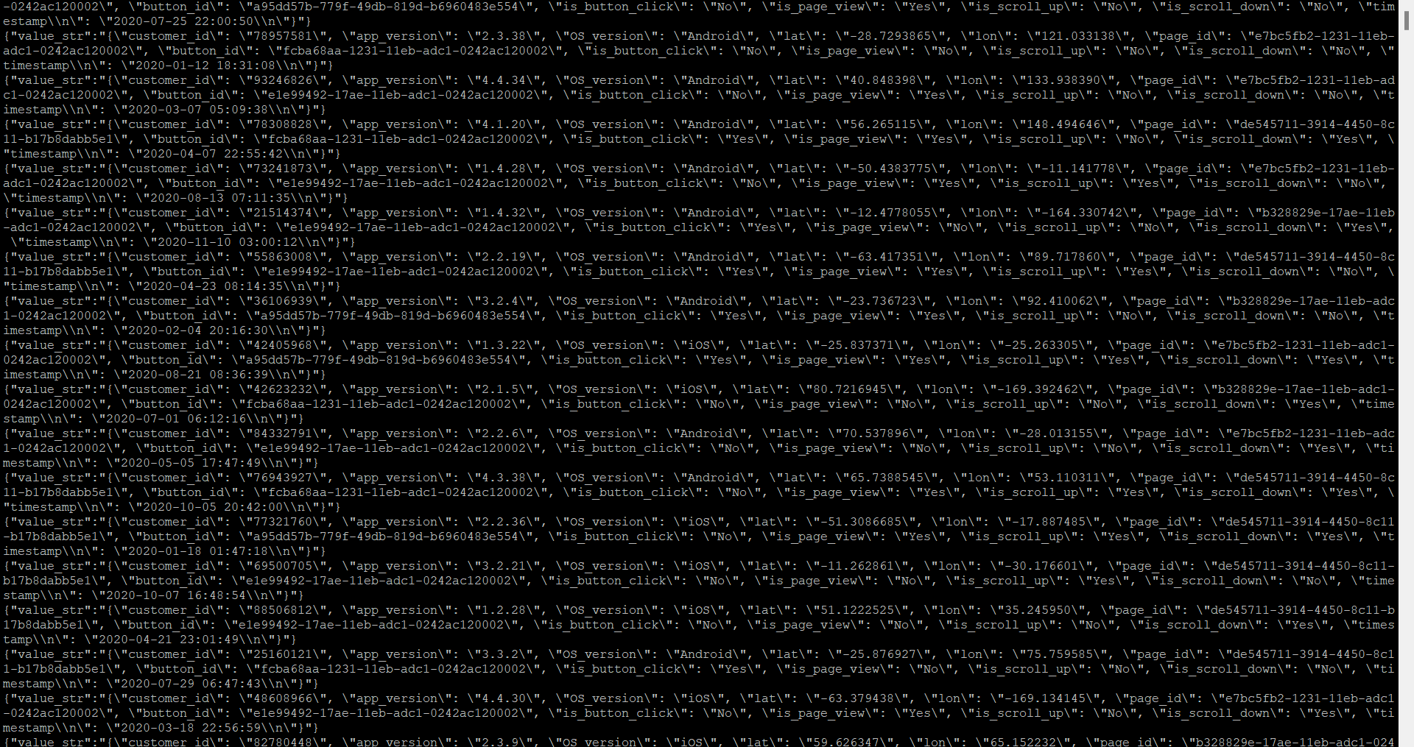

After loading data from Kafka to hadoop, we must flatten the data for analysis. So, I have created spark_local_flatten.py using pyspark.

**Task 2: Write a script to ingest the relevant bookings data from AWS RDS to Hadoop.**

1. Import all libraries required for running the code.

import os

import sys

os.environ["PYSPARK_PYTHON"] = "/opt/cloudera/parcels/Anaconda/bin/python"

os.environ["JAVA_HOME"] = "/usr/java/jdk1.8.0_161/jre"

os.environ["SPARK_HOME"] = "/opt/cloudera/parcels/SPARK2-2.3.0.cloudera2-1.cdh5.13.3.p0.316101/lib/spark2/"

os.environ["PYLIB"] = os.environ["SPARK_HOME"] + "/python/lib"

sys.path.insert(0, os.environ["PYLIB"] + "/py4j-0.10.6-src.zip")

sys.path.insert(0, os.environ["PYLIB"] + "/pyspark.zip")

from pyspark.sql import SparkSession

from pyspark.sql.functions import *

1. Initialize the Spark Session and name app Name as Kafka to HDFS

spark=SparkSession.builder.appName("Kafka-to-HDFS").master("local").getOrCreate()

spark

1. Read raw json file which is stored in HDFS.

df=spark.read.json("clickstream.json")

1. Select the columns for analysis.

df=df.select(get_json_object(df['value_str'],"$.customer_id").alias("customer_id"),

get_json_object(df['value_str'],"$.app_version").alias("app_version"),

get_json_object(df['value_str'],"$.OS_version").alias("OS_version"),

get_json_object(df['value_str'],"$.lat").alias("lat"),

get_json_object(df['value_str'],"$.lon").alias("lon"),

get_json_object(df['value_str'],"$.page_id").alias("page_id"),

get_json_object(df['value_str'],"$.button_id").alias("button_id"),

get_json_object(df['value_str'],"$.is_button_click").alias("is_button_click"),

get_json_object(df['value_str'],"$.is_page_view").alias("is_page_view"),

get_json_object(df['value_str'],"$.is_scroll_up").alias("is_scroll_up"),

get_json_object(df['value_str'],"$.is_scroll_down").alias("is_scroll_down"),

get_json_object(df['value_str'],"$.timestamp").alias("timestamp")

)

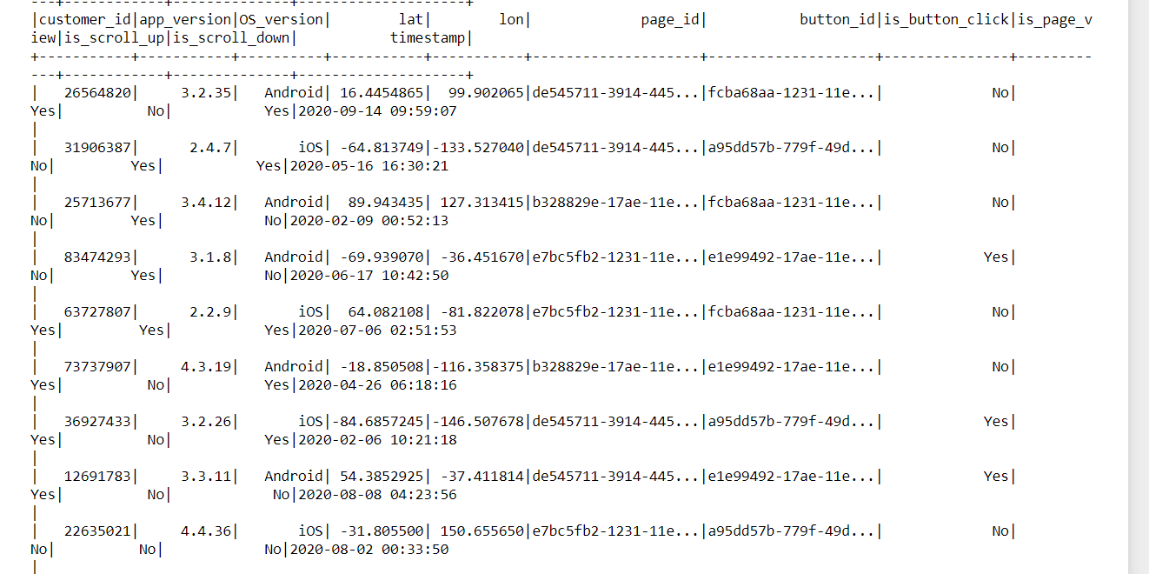

1. Write the flattened data to HDFS.

df.coalesce(1).write.format('csv').mode('overwrite').save('/user/root/clickstream_flattened',header='true')

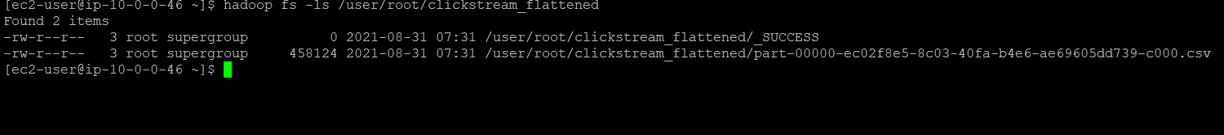

**Task 3: Create aggregates for finding date-wise total bookings using the Spark script.**

Before performing aggregates for datewise bookings, we have to load the data from AWS RDS to Hadoop using Sqoop import job. Below is the sqoop import job.

sqoop import \

--connect jdbc:mysql://upgraddetest.cyaielc9bmnf.us-east-1.rds.amazonaws.com/testdatabase \

--table bookings \

--username student --password STUDENT123 \

--target-dir /user/root/cab_rides \

-m 1

1. First import all required libraries

import os

import sys

os.environ["PYSPARK_PYTHON"] = "/opt/cloudera/parcels/Anaconda/bin/python"

os.environ["JAVA_HOME"] = "/usr/java/jdk1.8.0_232-cloudera/jre"

os.environ["SPARK_HOME"]="/opt/cloudera/parcels/SPARK2-2.3.0.cloudera2-1.cdh5.13.3.p0.316101/lib/spark2/"

os.environ["PYLIB"] = os.environ["SPARK_HOME"] + "/python/lib"

sys.path.insert(0, os.environ["PYLIB"] +"/py4j-0.10.6-src.zip")

sys.path.insert(0, os.environ["PYLIB"] +"/pyspark.zip")

from pyspark.sql import SparkSession

from pyspark.sql.functions import *

1. Initialize the Spark session.

spark=SparkSession.builder.appName("datewise_bookings_aggregates_spark").master("local").getOrCreate()

1. Read the data from HDFS which was loaded using Sqoop.

df=spark.read.csv("/user/root/cab_rides/part-m-00000")

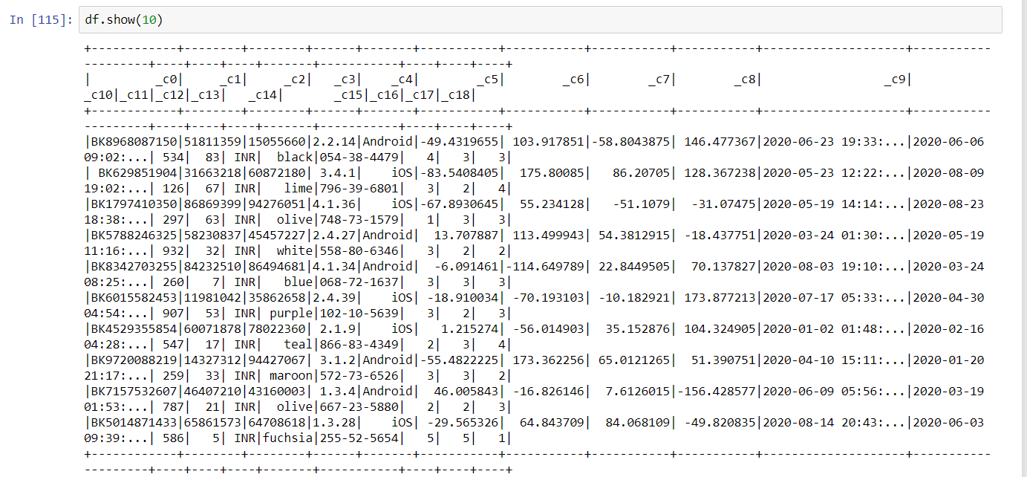

1. Rename the columns

* new_col = ["booking_id","customer_id","driver_id","customer_app_version","customer_phone_os_version","pickup_lat","pickup_lon","drop_lat","drop_lon","pickup_timestamp","drop_timestamp","trip_fare","tip_amount","currency_code","cab_color","cab_registration_no","customer_rating_by_driver","rating_by_customer","passenger_count"]
* new_df = df.toDF(*new_col)

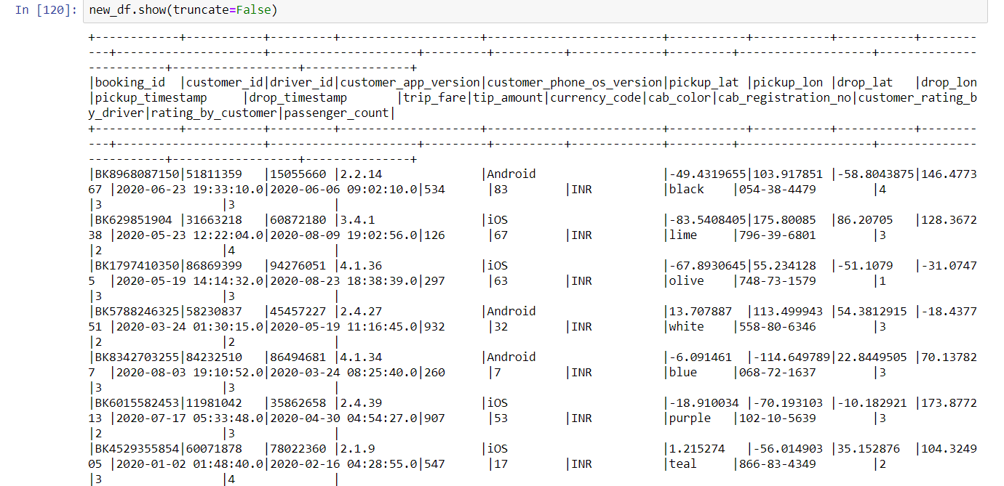

1. Converting pickup_timestamp to date by extracting date from pickup_timestamp for aggregation

new_df=new_df.select("booking_id","customer_id","driver_id","customer_app_version","customer_phone_os_version","pickup_lat","pickup_lon","drop_lat", "drop_lon",to_date(col('pickup_timestamp')).alias('pickup_date').cast("date"),"drop_timestamp","trip_fare","tip_amount","currency_code","cab_color","cab_registration_no","customer_rating_by_driver", "rating_by_customer","passenger_count")

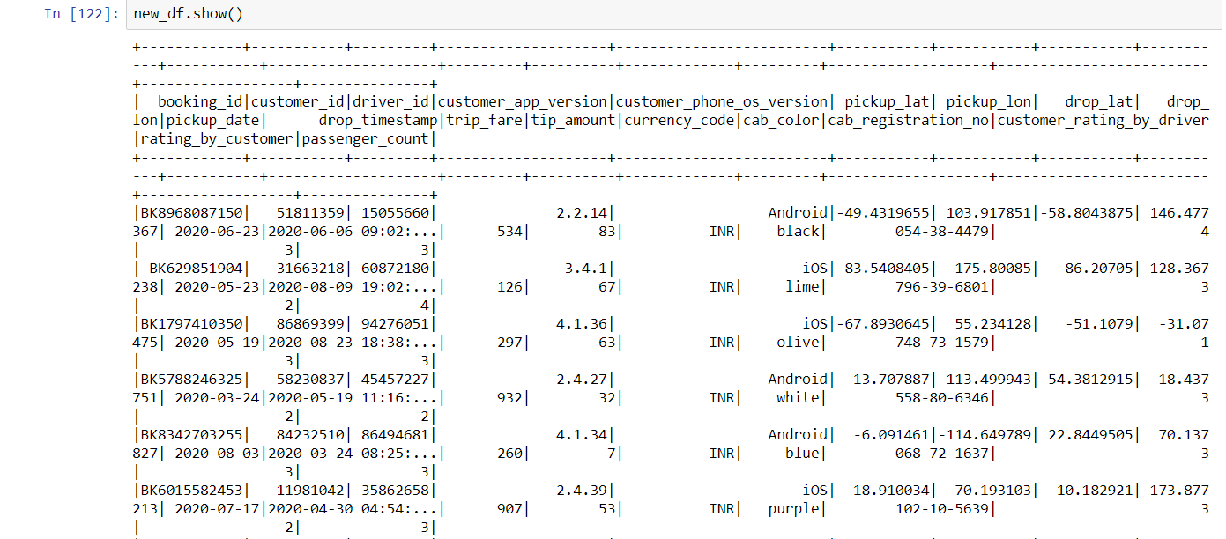

1. Aggregation on pickup date.

agg_df=new_df.groupBy("pickup_date").count().orderBy("pickup_date")

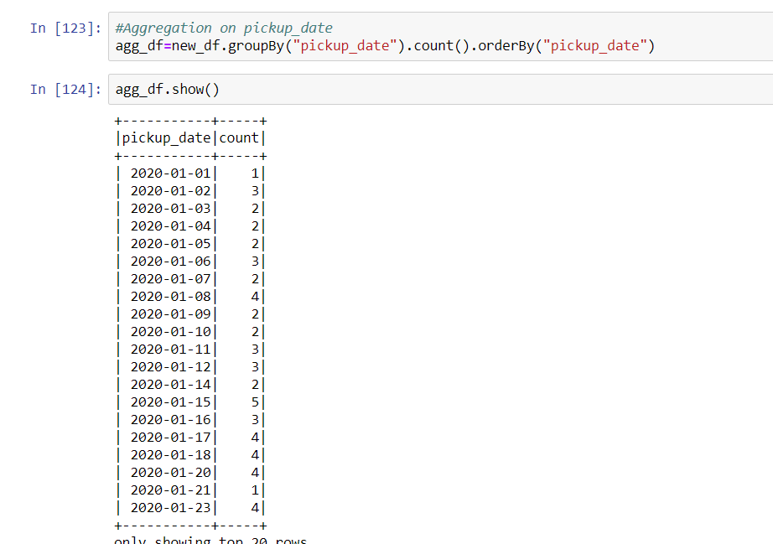

1. Command to move above grouped data into HDFS.

agg_df.coalesce(1).write.format('csv').mode('overwrite').save('/user/root/datewise_bookings_agg',header='true')



**Task 4:**

* **Create a Hive-managed table for clickstream data.**
* **Create a Hive-managed table for bookings data.**
* **Create a Hive-managed table for aggregated data in Task 3.**

For Creating tables in Hive, first we must create databases. I have created capstone database in Hive. The tables which I have created for all three tasks are clickstream, Booking, Aggregate_datewise. Here the data is stored in csv format, so while creating tables, we have to use fields terminated by , .

1. **Clickstream data: Hive Managed table.**

create table if not exists clickstream (

customer_id int,

app_version string,

os_version string,

lat double,

lon double,

page_id varchar(100),

button_id varchar(100),

is_button_click string,

is_page_view string,

is_scroll_up string,

is_scroll_down string,

timestamp timestamp )

ROW FORMAT DELIMITED

FIELDS TERMINATED BY ','

stored as textfile;

Load data into the table using below command.

load data local inpath '/root/clickstream/clickstream_flattened.csv' into table clickstream

1. **Bookings data:**

create table if not exists booking (

booking_id string,

customer_id int,

driver_id int,

customer_app_version string,

customer_phone_os_version string,

pickup_lat double,

pickup_lon double,

drop_lat double,

drop_lon double,

pickup_timestamp timestamp,

drop_timestamp timestamp,

trip_fare int,

tip_amount int,

currency_code string,

cab_color string,

cab_registration_no int,

customer_rating_by_driver varchar(100),

rating_by_customer int,

passenger_count int)

ROW FORMAT DELIMITED

FIELDS TERMINATED BY ','

stored as textfile;

Load data into the table using below command.

load data local inpath '/root/booking_data/part-m-00000' into table booking;

1. **Aggregated data datewise:**

create table if not exists aggregate_datewise(

pickup_date date,

booking_id_count int

)

ROW FORMAT DELIMITED

FIELDS TERMINATED BY ','

stored as textfile;

Load data into the table using below command.

load data local inpath '/root/agg_datewise' into table aggregate_datewise;